Dexter Slideshow Sample Application

Description:
The Dexter Slideshow Sample Application is a GUI based tool to create multi media slide shows and to be able save them to an .XTL file or render them to an .AVI file.

Path
Source: (SDK root)\Samples

User Guide
This sample application demonstrated the following tasks related to multimedia slideshows in VB.

- Drag and drop support for adding files to the slideshow.
- Saving current slide show to a .XTL file
- Rendering the current slideshow to an .AVI file.
- Loading Media clips from the following file formats.
  - .AVI files
  - .MPG file
  - .JPG files

When the application is first started you should see the following UI.
The UI is broken down into the following parts.
- Frame cells
- Dry Time and transition properties for all the clips.
- Buttons
  - Play
  - Write XTL
  - Write AVI
  - Exit
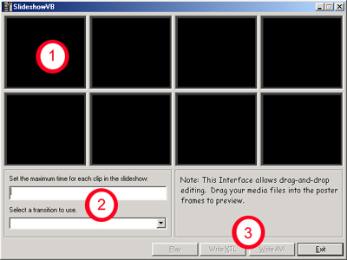

Once the application is loaded you can start to insert media into the cells. Starting in the upper left hand cell, working your way across the app.

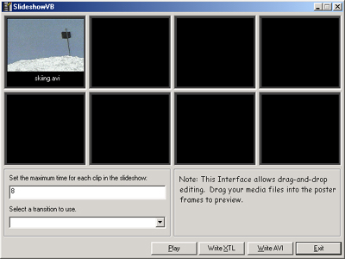

Next you can assign the length of the clip (dry time) and the transition to be used to go to the next clip. These times are used for all the clips in the movie. Transition times between the clips are set to 2 second. So a dry time of 3 seconds plus the 2 second transition will result in a 5 second clip. When all the clips are in place and the clip length and transitions are done you can save the movie in XML format by write XTL. This will open the Windows common dialog box to prompt you for the path and location where to write the .XTL file.

To create the new movie from the clips press the write AVI file. This will create a new AVI in uncompressed AVI format.

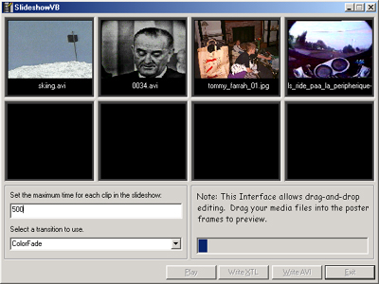

The progress bar will show the percentage completion of creating the new AVI file.

